**Cloud Formation:**

AWS **CloudFormation** simplifies provisioning and management on AWS. You can create **templates** for the service or application architectures you want and have AWS **CloudFormation** use those **templates** for quick and reliable provisioning of the services or applications (called “stacks”).

**Template** means Json file format of writing code which service you’re going to create .

Open Visual studio code:

Install **Cloud formation** plug-in:

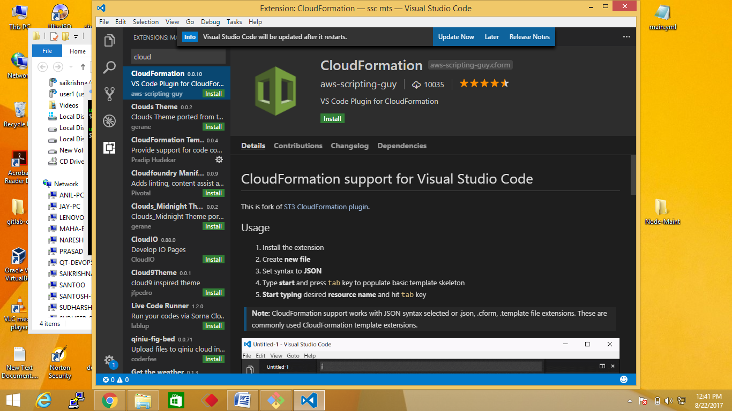

Step1: Create a Json file:

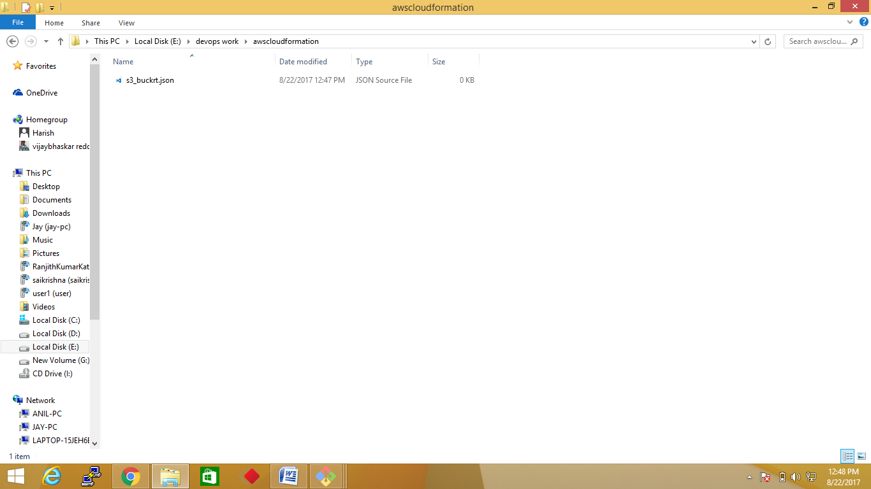

Step2: write a code for creating s3 bucket.

In any Aws service creation by using Cloud formation must be constriction on five steps:

1.Version of template it should be common for all

"AWSTemplateFormatVersion":"2010-09-09",

2. Description:

Description":"Example template",

3. Parameters: Use this if you want pass any values to the cloud formation template through manually.

4. Recourse: Describe what action you’re going to do {ex: creating s3-bucket} in this recourse section

In this resource use Type: to declare aws service

"Type":"AWS::EC2::Volume",

5. Output: if you want see final output write a code in this section

Step3: write code

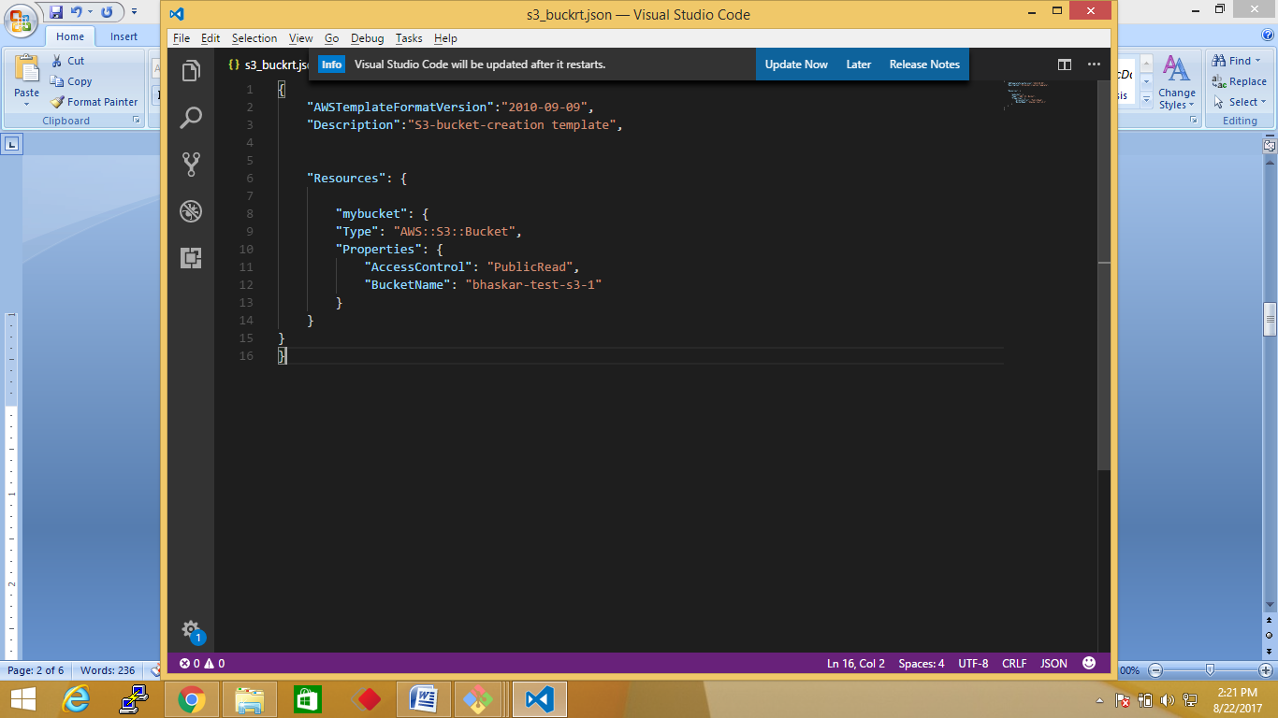

Step4: login into you’re aws account

Step5: Go to services click on cloudformation

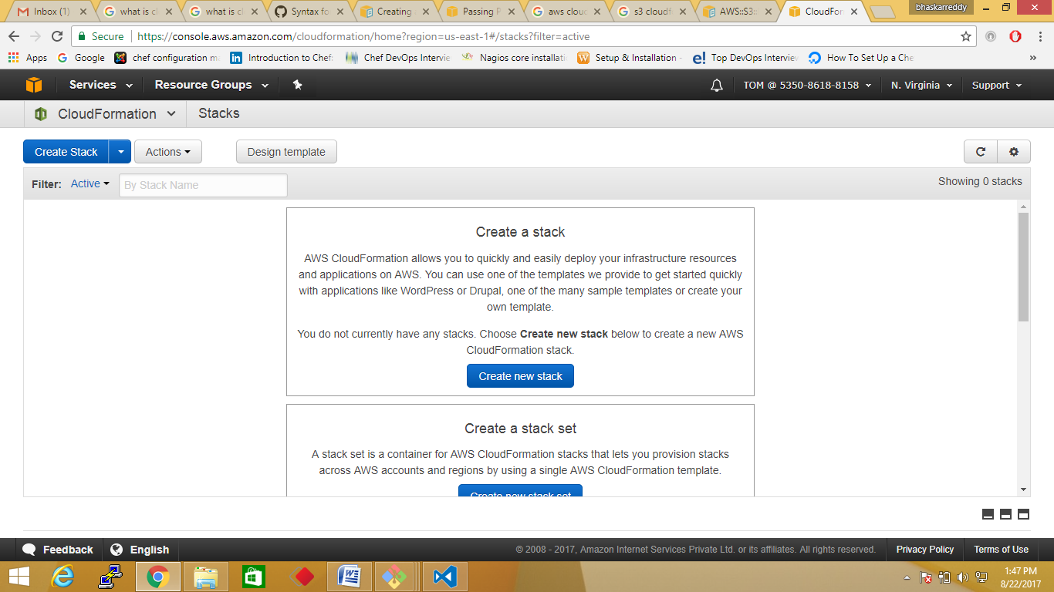

Step6: click on create stack

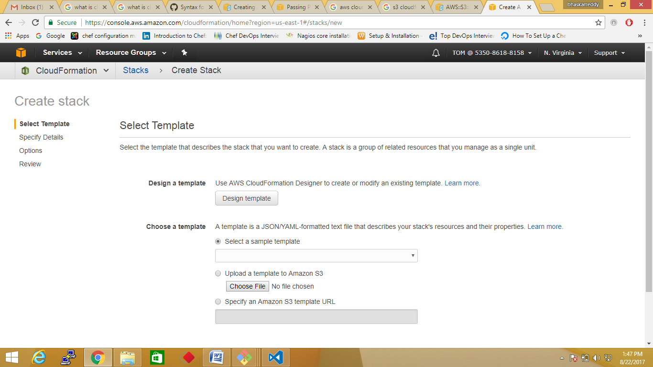

Step7: upload you’re file and click next

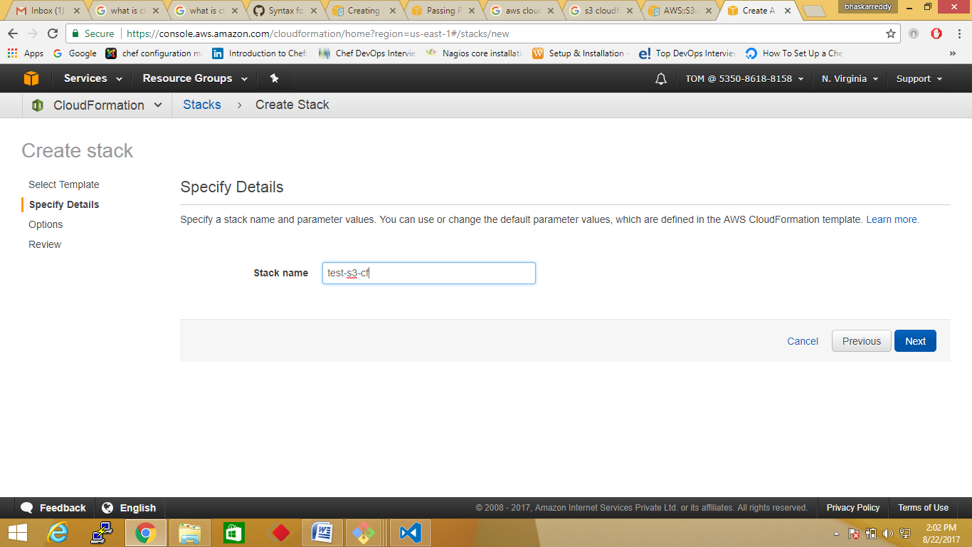

Step8: Give stack name what ever you want then click next and next and then create

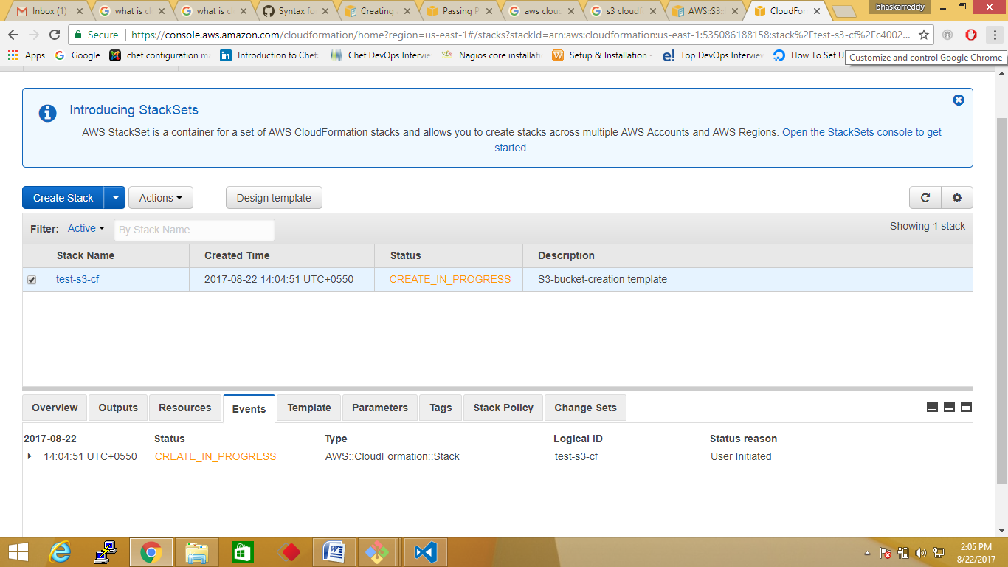

Step9: when the status of bellow screen turn to green , i.e: successfully uploaded stack

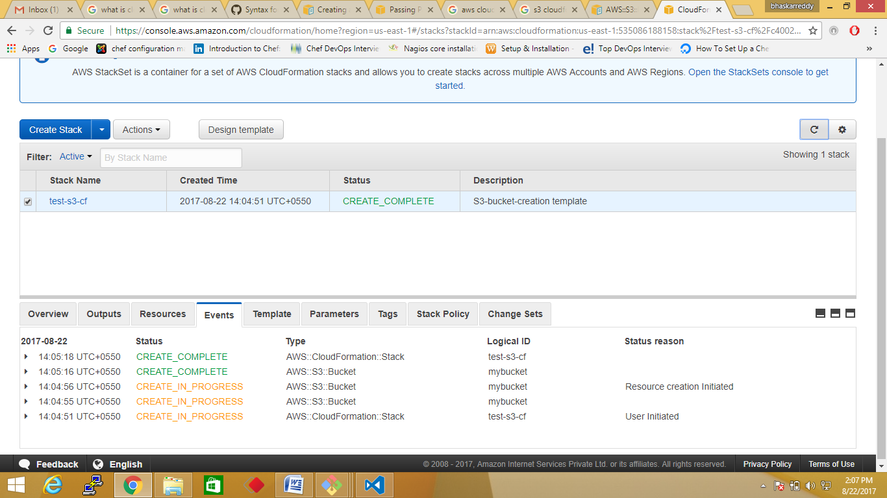

Step10: Chck in Ui in s3 service whether the bucket is created or not

